**PROJECT REPORT TEMPLATE TEAM ID – NM2023TMID32321**

**1. INTRODUCTION**

1.1 OVERVIEW:

Each employee must submit an electronic request in the system for future travel. Each request includes a list of estimated expenses for airfare, hotel, rental cars, and so on. Each request must be approved by the employee’s manager, and all out-of-state travel must be.

1.2 PURPOSE:

This project is used to create a relationship between the customer and owner. The main objective of pre-trip approval is to control undesirable travel buying behaiviours of employees and cost. The approver verifies the travel request according to the travel policy of the corporate and decides to approve or decline.

**2. PROBLEM DEFFENITION AND DESIGN THINKING**

2.1 EMPATHY MAP

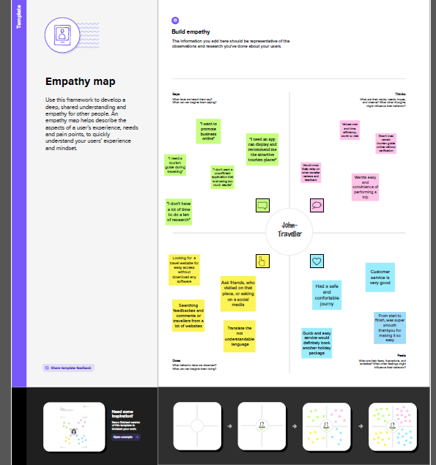

2.2 IDEATION AND BRAINSTROMING MAP

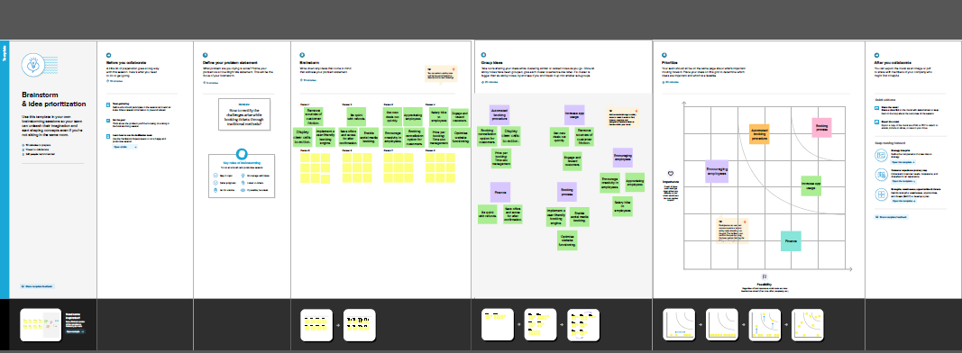

**3. ACTIVITY AND SCREEN SHOT:**

MILESTONE : 1

Activity 1: Creating developer account

A developer org is ceated in salesforce. Signup from is filled and a new username and password is created. Account is activated by the email received and the account gets verified and developer account gets created.

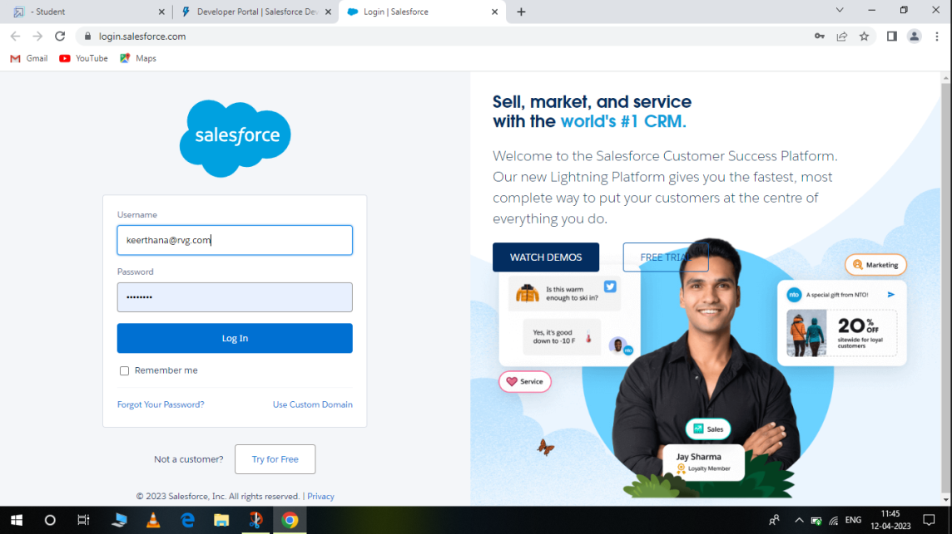

MILESTONE : 2

Activity : 1 (Create 3 custom objects)

* 3 custom objects Department,Travel Approval, Expense item

Enter the label name, plural label name, click on allow reports, allow search-- Save

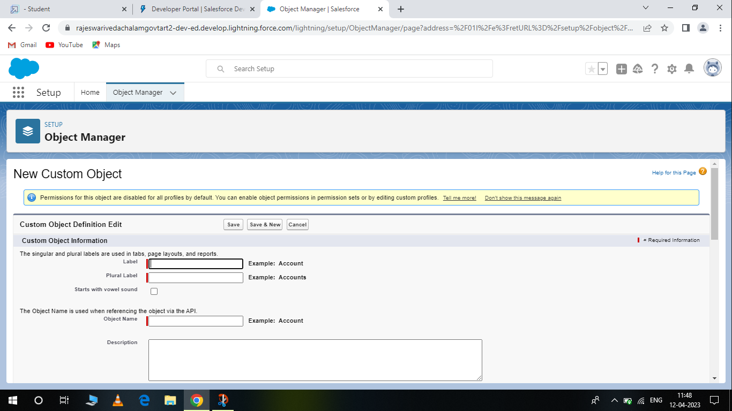

**CREATE DEPARTMENT OBJECT**

1. From setup, click Object Manager

2. Click Create , then select custom object

3. Give the name as department

**CREATE TRAVEL APPROVAL OBJECT**

1. Navigate back to object manager

2. Click create then select custom object

MILESTONE : 3 (WHAT IS A TAB?)

Activity : 1

Now create a custom tab. Click the home tab, Enter tabs in quick find and select tabs. Under custom object tabs, click new.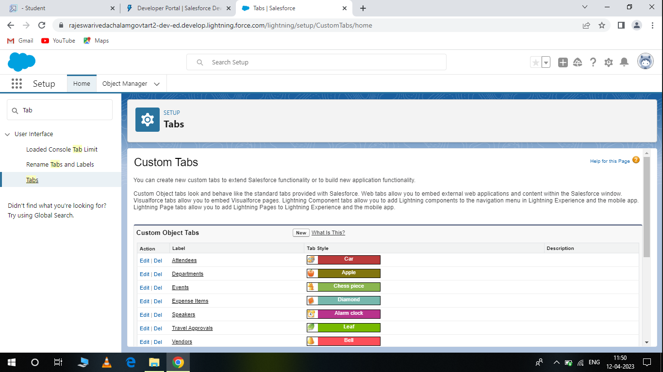

1. For object, Select event.

2. For tab Style, select any icon.

3. Leave all defaults as is Click next, next and save.

MILESTONE : 4 (Create-Fields & Relationship)

Activity : 1

1. Click Fields and relationships and Click new.

2. For datatype select currency.

3. Enter this details.

a. For field label enter amount.

b. For length enter 16.

c. For decimal places, enter 2.

d. Select required.

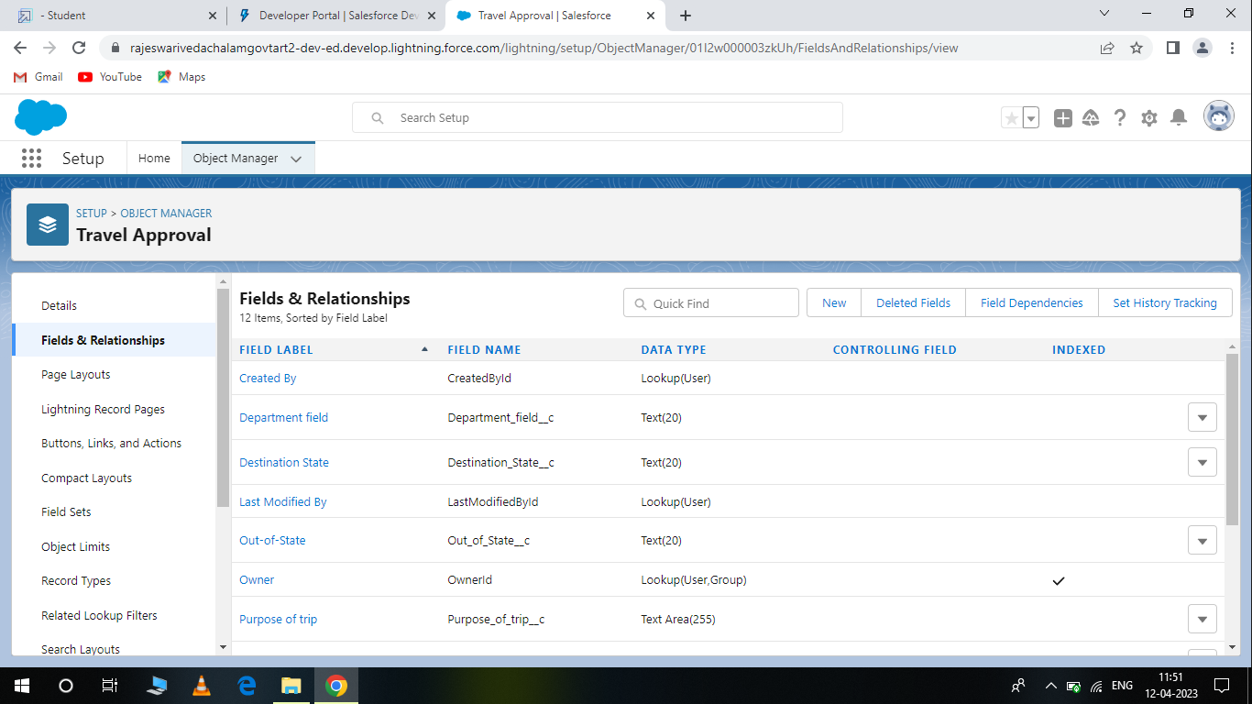

4. Click next, next, then Save and new.

MILESTONE : 5 (Creating the Aplication)

Activity : 1

From setup, Enter app manager in the quick find and select app manager.

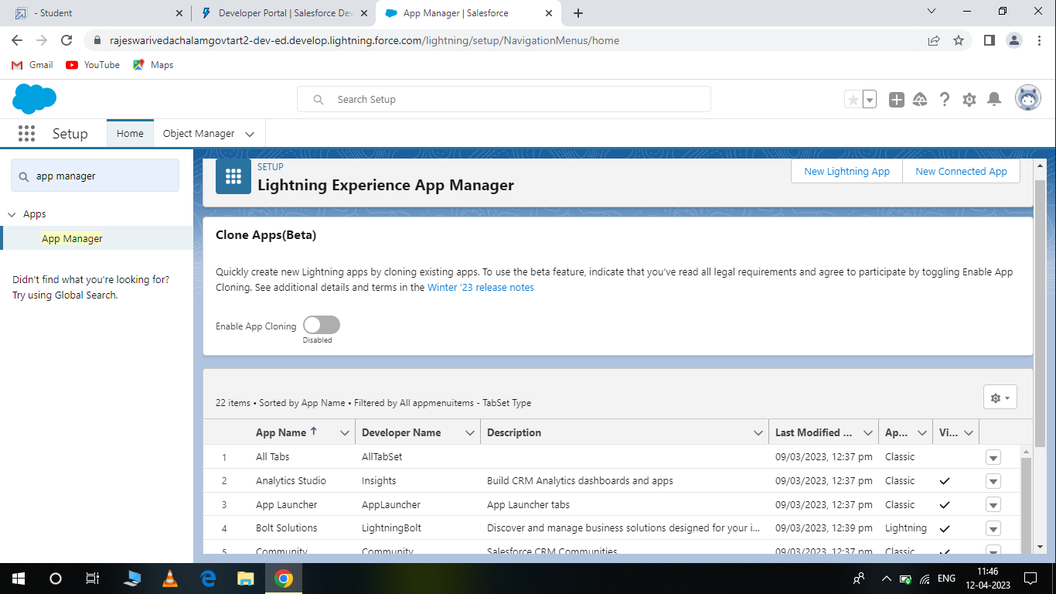

From available items, select department, travel approval, expense item, reports and dashboards and move them to selected items click next.

From available profiles, select system administrator and move in to selected profiles. Click save and finish.

MILESTONE : 6 (Import Deportments)

Acttivity : 1

1. In the quick find box, enter data import and select data import wizard.

2. To click launch wizard!

3. Next, select add new records.

4. Drag and Drop the departments. csv file you downloaded using zip file or click the CSV icon and brows to select your file.

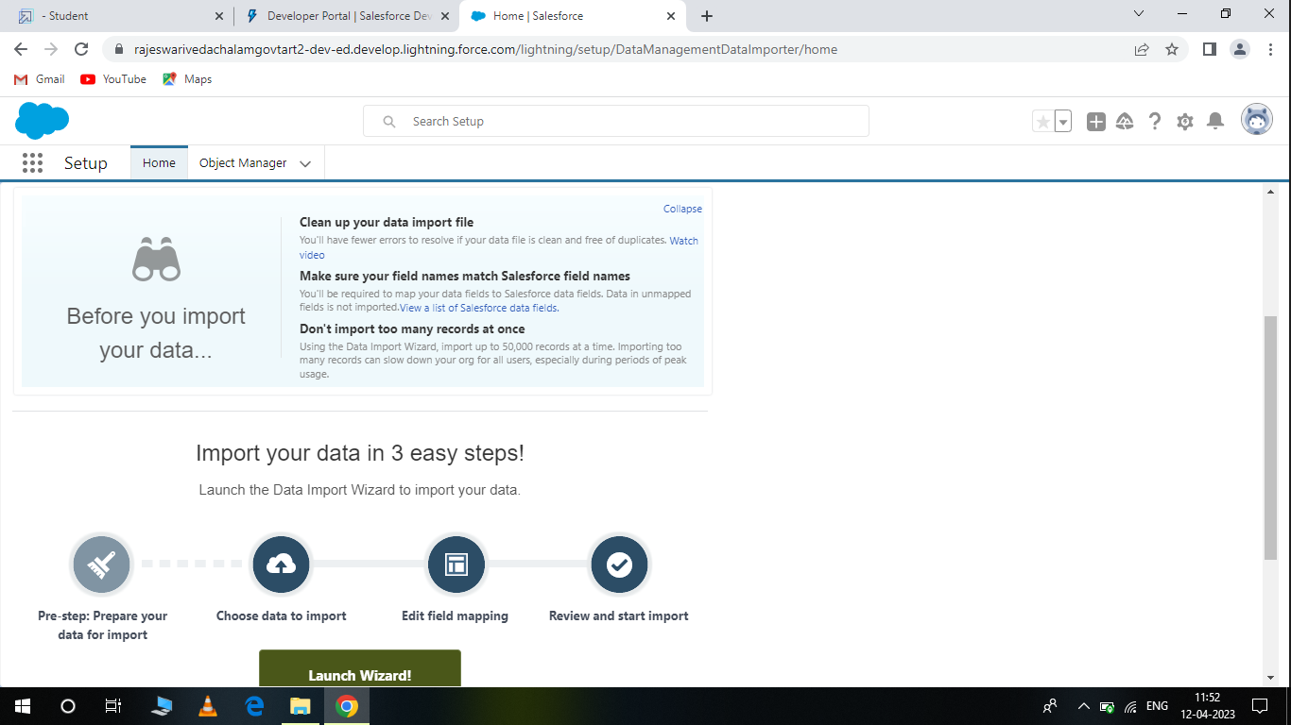

MILESTONE : 7 (Customize user interface)

Activity : 1

Create user and setup approvals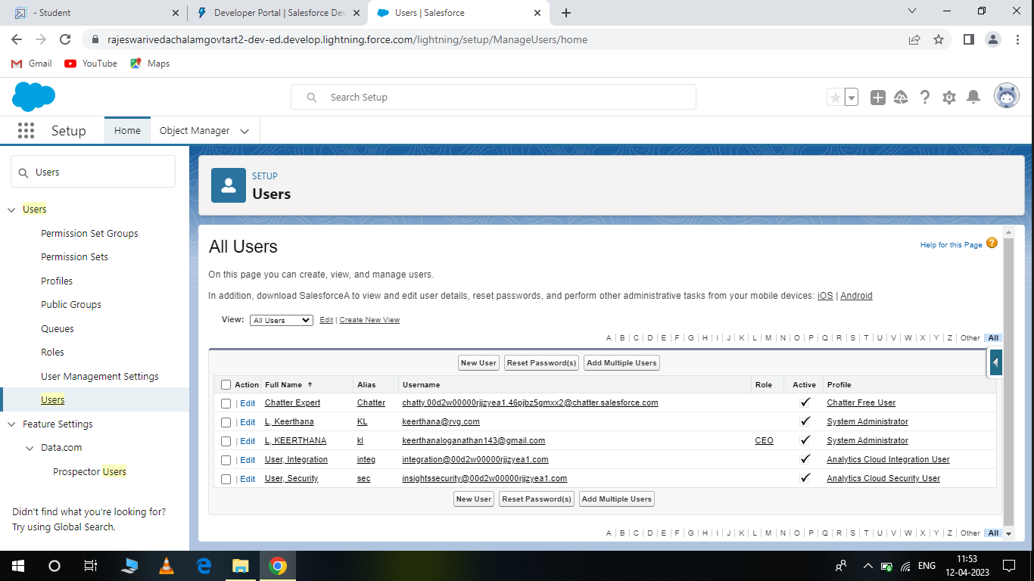

1. Enter users in the quick find box and select users.

2. Click new user.

3. Now give the name as you wish but the email must be real email address.

4. For user name filled follow the instructions.

MILESTONE : 7 (Use customization)

Activity : 1

Customize travel approval object pag layout.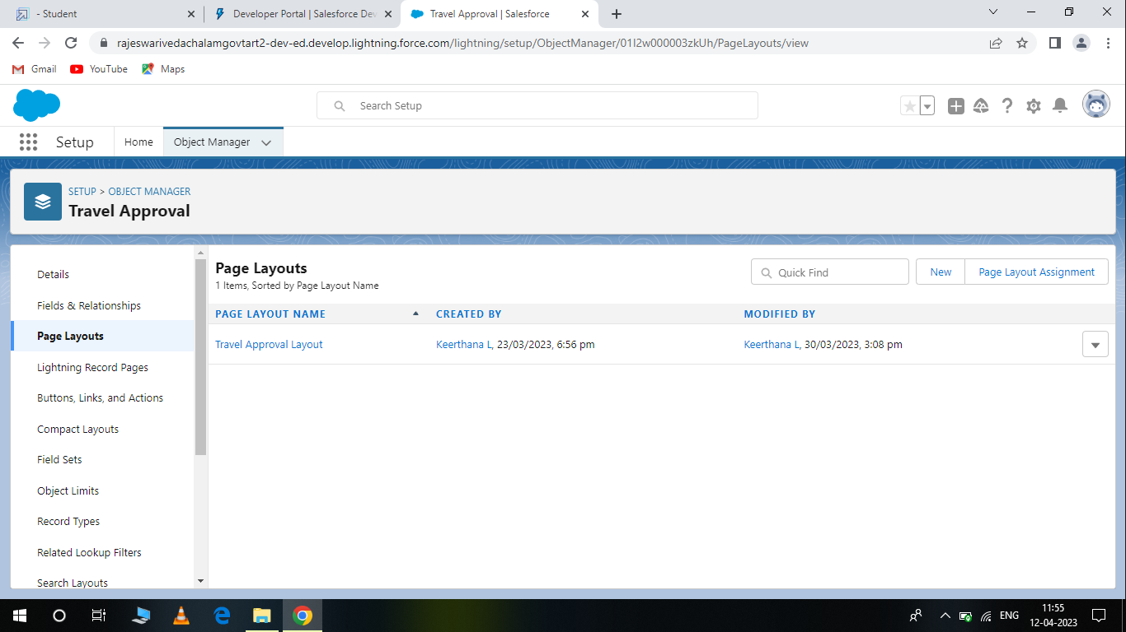

Customization refers to custom software development and coding to add robest features to your CRM platform. This features can be integrated with your business to have a scalable impact.

MILESTONE : 9 (Add business logic to travel app)

Activity : 1

Create validation rule

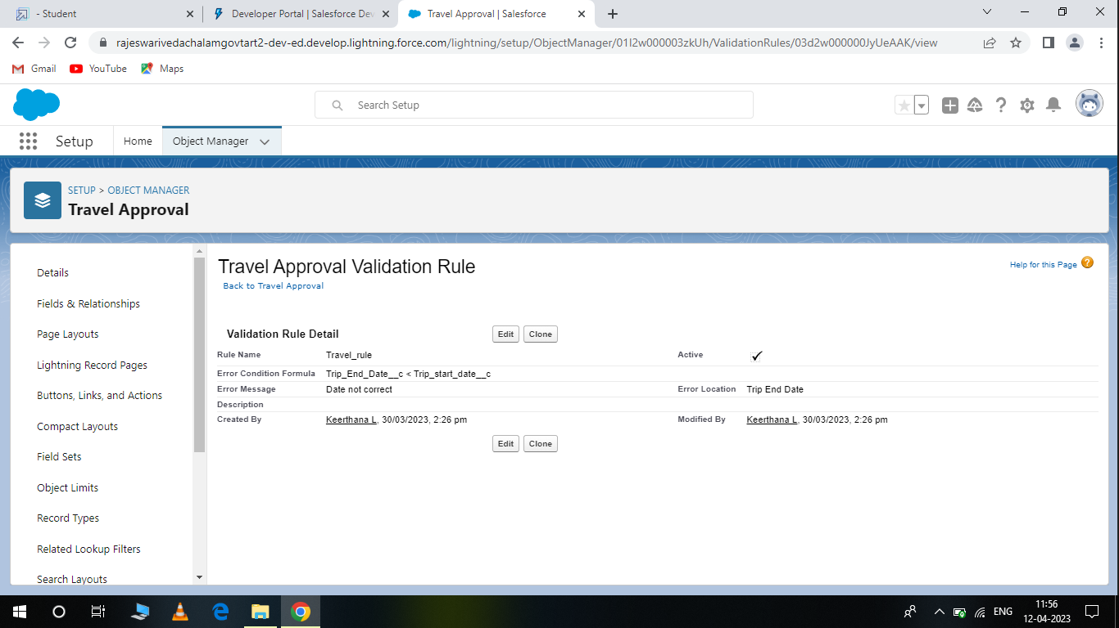

From this milestone we are going to create validation rule, rollup summary fields, formula fields, work flows and approval process.

MILESSTONE : 10 (What are reports?)

Reports in sales force is a list of records that meet a particular criterion which gives an answer to a particular question. These records are displayed as a table that can be filtered are grouped based on any field.

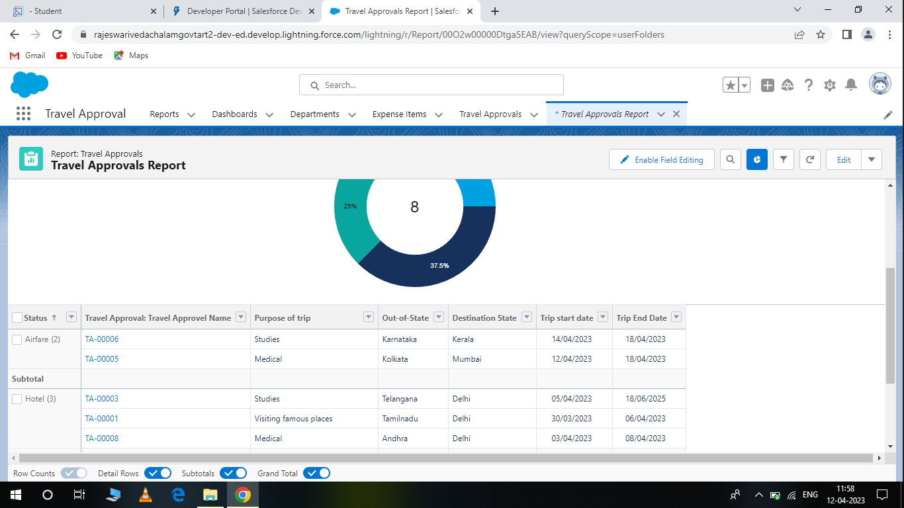

MILESTONE : 11 ( Dashboards)

Dashboards let you create data form reports using chats, tables, and metrics. If your collegus need more information, then they are able to give your dashboards data-supplying reports. Dashboard filters make it easy for users to apply different data perspectives to a single dashboard.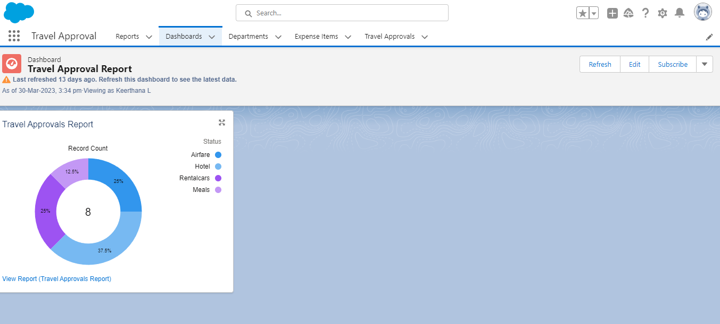

**TRAILHEAD PROFILE PUBLIC URL:**

Team lead (Keerthana L) **-** https://trailblazer.me/id/kloganathan6

Team member 1 (Indhumathi S) - https://trailblazer.me/id/indhs7

Team member 2 (Komathi T.M) **-** https://trailblazer.me/id/komtm

Team member 3 (Komathi E) **-** https://trailblazer.me/id/kelumalai11